[](https://www.google.co.uk/url?sa=i&rct=j&q=&esrc=s&source=images&cd=&ved=2ahUKEwjg2I3eqKTaAhUBtBQKHWpNCUoQjRx6BAgAEAU&url=https://www.pinterest.com/pin/469218854920862851/&psig=AOvVaw1NMet86t6E4821SckIC7UJ&ust=1523058295211917)

KINGSCOTE & BAGPATH DEFIB FUNDRAISING & WEDDING EVENT

RAFFLE PRIZES

**SUDDEN CARDIAC ARREST** IS THE UK’S BIGGEST KILLER

Watch out for further local fundraising events

[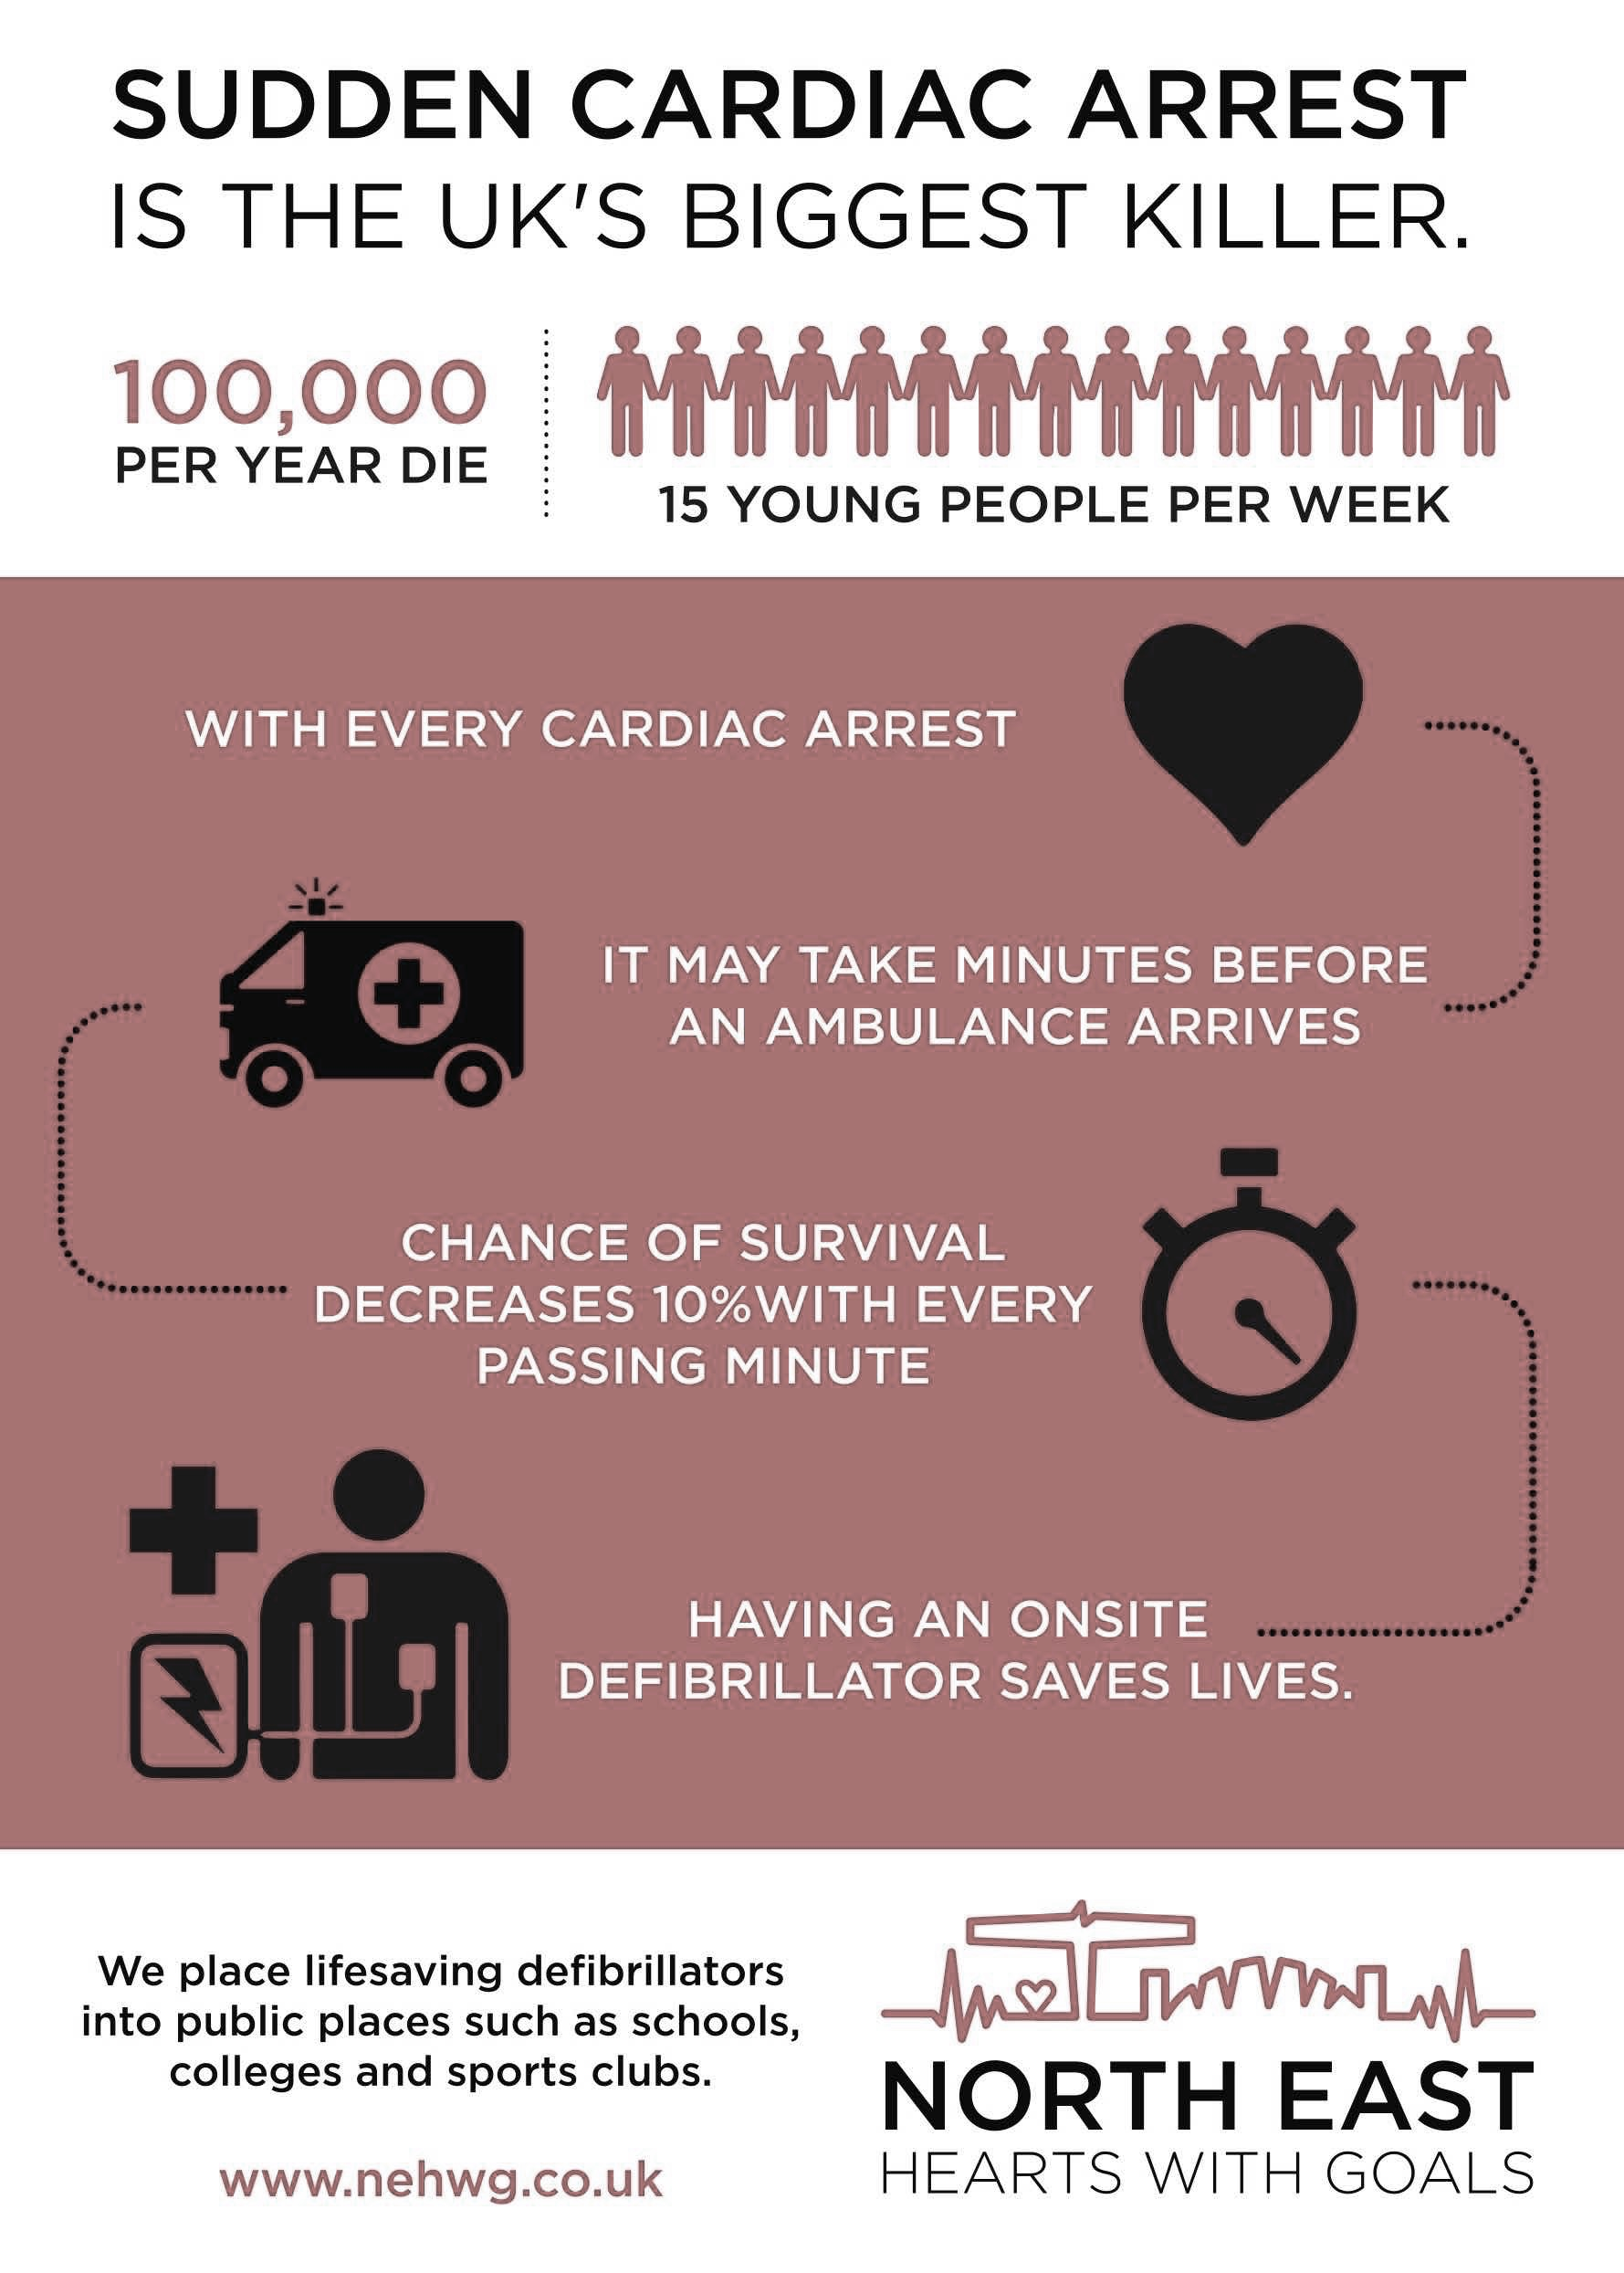](https://www.google.co.uk/url?sa=i&rct=j&q=&esrc=s&source=images&cd=&ved=2ahUKEwjI95qmr6TaAhVFUhQKHWNjBHoQjRx6BAgAEAU&url=https%3A%2F%2Fwww.goldengiving.com%2Fcharity%2Fnorth-east-hearts-with-goals&psig=AOvVaw3O6WRL_pNjo9pGGjnKXgcX&ust=1523060131217523)

----

Brewery Tour donated by Windsor & Eton Brewery

A Month’s Gym Membership donated by BPF Fitness Hub, Tetbury

A Family Photoshoot donated by Rupert Marlow, Bagpath *

Garden parasol donated by Bramblecrest, Frampton Mansell

Dinner for Two donated by Egypt Mill, Nailsworth *

£15 voucher donated by Hobbs House Bakery, Nailsworth

Pocket Filofax donated by Pulp, Nailsworth

Bottle of wine donated by Vinotopia, Tetbury

* Conditions apply

Draw to take place at KINGSCOTE VILLAGE HALL, Sunday 20th May, 3-5pm